Template Information & Press Summary
VTE - YOU and ME
Anyone can develop a VTE, regardless of age, gender, ethnicity or general health.
A VTE (venous thromboembolism), or a thrombosis, is a condition in which life-threatening blood clots form in the artery or vein.
A clot in the vein (usually in the leg or pelvis) is known as a deep vein thrombosis (DVT) and a clot that breaks off and travels to the lungs is known as a pulmonary embolism (PE).
Together, DVT and PE make up venous thromboembolism (VTE).
Thrombosis does not discriminate. A recent high-profile patient was Serena Williams, a young and very fit athlete.
Thrombosis UK’s #LetsTalkClots national campaign, launching 1st May 2018 will focus on the importance of VTE as a national priority for patient safety, patient outcomes and NHS burden.

- 1:4 deaths as a result of causes related to blood clots
- 55%-60% of all blood clots result from hospitalisation
- VTE is the number 1 cause of preventable deaths in hospital

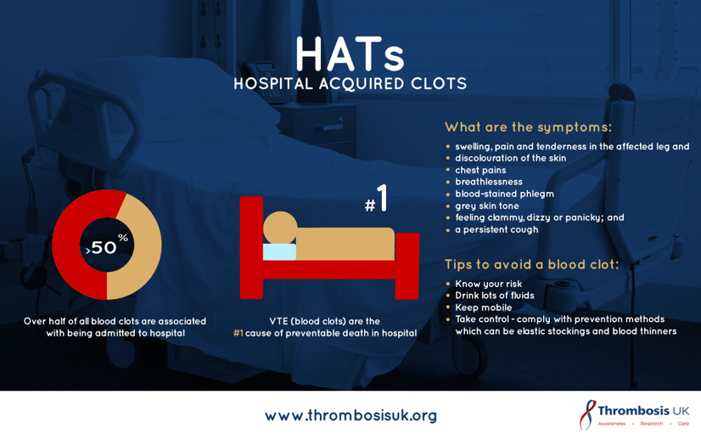

Let’s Talk Clots will provide CPD accredited conferences, Patient Information meetings and awareness events across the UK, [INSERT LOCAL EVENT HERE].

The Let’s Talk Clots campaign shares three key messages:

For Healthcare Professionals:
- Think Thrombosis – risk assess everyone being admitted into hospital, whilst there and at discharge
- Prevention saves lives, burden and cost to NHS
- 80% of people presenting with a DVT have no symptoms, always consider VTE & investigate

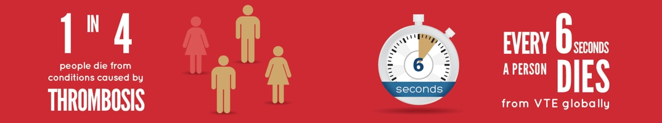

For Everyone:
- Think Thrombosis – A blood clot can occur in anyone at any time without warning
- Keep active & be aware of risk factors
- If you think you may have a blood clot – seek urgent medical attention

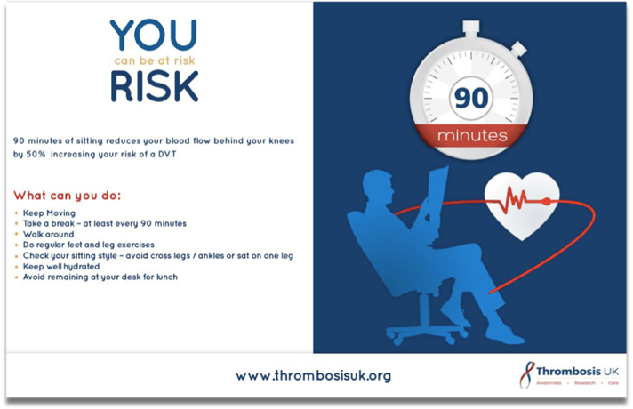

For further information contact jo@thrombosisuk.org
Visit: www.thrombosisuk.org

Follow us on Twitter @ThrombosisUK
#LetsTalkClots
#KnowThrombosis

Extra information:

Venous thromboembolism (VTE) is the number 1 cause of preventable deaths in hospital

Venous thromboembolism is a leading cause of death and disability worldwide. In Europe and the U.S., it claims more lives than AIDS, breast and prostate cancer, and motor vehicle crashes combined.

1 in 4 people worldwide are dying from conditions caused by thrombosis

The top three cardiovascular killers are linked to blood clots

